HF&G members come join us for the first ever--------------
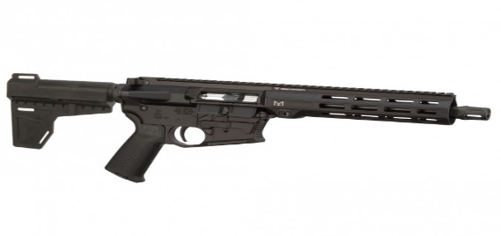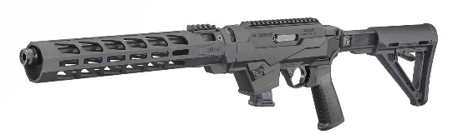
Pistol Caliber Carbine
Practical Scenario Shooting League
Tuesdays in June
(June 8, 15, 22 and 29th)
5PM till Sunset
Different Scenarios each week
10 rounds max/magazine

Questions Call: Mike Vasil
203-387-3675

