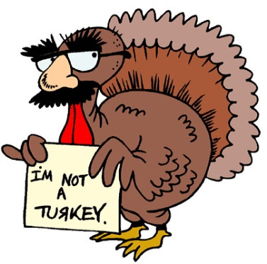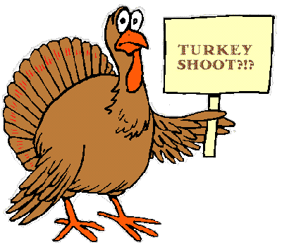

TURKEY SHOOT

Time: 9:30am—1:30pm

October 16th, 2021

Events Include:

-Mo Skeet

-Black Powder Rifle

-Pistol Egg Shoot

-Archery

-Motorized Running Deer*

*(Bring your deer rifle)

-Splatter Gun

-BB Gun Shoot

-Double Skeet

-Trap & Skeet

-_

Run by Skilled &

Professional Sportsmen

Open to the Public

Location: Hamden Fish & Game 155 Willow StreEt, Hamden, CT

All Ages Welcome

Safe & Courteous

Food and fun